Biodiversity Conditions and Policy Implications of a
Smallholder-Protected Forest Ecosystem in Leyte, Philippines
Arturo E. Pasa
College of Forestry and Natural Resources,
Visayas State University, Visca, Baybay, Leyte, 6521-A Philippines

KeywordS: Threatened species, Wildlife hunting, CBFM Project, Eco-Tourism

Abstract

A study was conducted to assess the floral and faunal diversity within the smallholder-protected forest ecosystem in Midwestern Leyte Province, Philippines. A total of 1,903 plants belonging to 325 species and 93 animal species were recorded based from actual survey and ethno-faunal assessment. There were 648, 676, and 579 plants recorded for the protected zone, buffer zone, and multiple-use zone, respectively. Recorded fauna included 11 species of mammals belonging to nine families, 39 species of birds belonging to 20 families, 16 species of reptiles belonging to nine families, and 27 species of amphibians belonging to five families. Eight globally threatened faunal species are still found in the area. The same faunal species will soon vanish if wildlife hunting will continue. Ecotourism is slowly coming into the picture which may also become a problem in the next few years. Information and education campaign on biodiversity conservation as well as alternative livelihood opportunities for smallholders are essential to maintain the enormous ecological functions of that biodiversity frontier.

Introduction

Biodiversity is an issue with global importance. Lean et al. (1990) pointed out that even the loss of a species is a tragedy because each form of life is a storehouse of irreplaceable substances. They added that every civilization has been rooted in the wealth of nature. The domestication of wild species made the first farming possible; selective breeding made them more productive; and natural resources enabled the agricultural and industrial revolutions to take off. Genetic resources taken from the wild still sustain modern societies, providing medicines, food, and raw materials for the industry. Worldwide, medicines from wild products are worth some $US40 billion a year (Lean et al. 1990). In the United States 25 percent of pharmaceuticals contain ingredients originally derived from native plants, representing US$8 billion of annual revenue for drug companies (Nebel and Wright, 2000). Foxgloves have saved the lives of millions of sufferers from heart disease by providing digitoxin and digitalis. The snakeroot plant from the Indian forests relieves high blood pressure and hypertension. Bee venom is used to treat arthritis. Codeine and morphine come from poppies; an Amazonian tree provides quinine to fight malaria and curare and liana relaxes muscles for surgery and treats multiple sclerosis and Parkinson’s disease. The rosy periwinkle, a pretty but unremarkable plant discovered in Madagascar forests, has transformed the prospects of children with leukemia. Before its discovery, less than a fifth of the children survived; now two drugs taken from the plant, together with other treatments, have increased the remission rate to over 80 % (Lean et al. 1990). These two drugs now represent a US$100 million-a-year industry (Nebel and Wright, 2000). In all, 1,400 tropical forest plants yield chemicals with the potential to fight cancer; many may be driven to extinction before their promise can be assessed or tapped (Lean et al. 1990). Thus, conservation of the remaining global plant and animal resources is indispensable.

Biodiversity conservation seeks to maintain the human life support system provided by nature and the living resources essential for development (WRI-IUCN-UNEP 1992). It endeavors to sustain the global ecosystems services which are valued at US$33 trillion per annum (Costanza et al. 1997). However, global biodiversity conservation initiatives have been greatly hampered by population explosion, deforestation, and over-exploitation of natural resources which significantly reduced such ecosystems services. The Philippines is not an exception. The more than 7,100 islands, which form the Philippines, are home to some of the world's most unique species. The tropical climate, forests, and archipelagic formation of this country comprise one of the most globally significant regions for biodiversity. Unfortunately, this high rate of endemism and species diversity is impacted with extreme levels of socio-economic pressures. Deemed the 'hottest of the hotspots', the Philippines’ need for viable conservation solutions are as great as its unique biological heritage (Conservation International Philippines, 2002). Hence, the government has responded to the challenge of restoring the degraded uplands to enhance biodiversity in the entire country. This responsive strategy was implemented through the Community-Based Forest Management (CBFM) Project that directly involves the local people in protecting and managing the remaining forest lands. Determining the current state of biological diversity of CBFM projects however remains a challenging task. Any attempt to expose the biodiversity level therein either preliminary or exhaustive is certainly worthwhile as it reveals information on the current biodiversity conditions, biodiversity threats and local conservation initiatives.

Remarkably, many plants and animals are still unknown signifying enormous potentials that remain to be discovered. Probably less than five percent of the biological diversity of the rainforests is known to science (McNeely et al., 1990 cited by Schϋcking and Anderson, 1991). In 2000, Nebel and Wright pointed out that about 1.75 million species have been described and classified, but scientists estimate that up to 100 million still remain unidentified. Of the entire world’s currently identified species, only 10-15% lives in North America and Europe. The greatest concentration of different organisms tends to be in the tropics, especially in tropical rainforests (Cunningham et al. 2007). At present, however, nobody knows the total number of species that exist (www.panda.org 2005). That includes the diversity within the site of this study. Therefore, assessing biodiversity within the CBFM project becomes imperative to uncover various species of flora and fauna which have enormous ecological, social, economic as well as policy implications, thus this study.

MATERIALS AND METHODS

Study Site

The site of this study was the 2236 ha Community-Based Forest Management (CBFM) project located in the contiguous area of Barangay Gabas and Barangay Kilim in Baybay, Leyte, Philippines last May to October 2005. The site lies between 124⁰48’ longitude and 10⁰43’ latitude, having a climatic type IV with more or less evenly distributed rainfall throughout the year. On average, June to January are wet months while February to May are relatively dry. Average annual rainfall is 2500 mm while the average annual minimum temperature is 22.3⁰C and maximum is 33.67⁰C (PAGASA 2007). It is rugged and mountainous with slope ranging from 30 to 80 percent. The highest elevation is 986 m above sea level at the north-eastern part called Mt. Emik (CRMF c2002).

The CBFMP site has three land use classifications, namely: 1) protected zone, 2) buffer zone, and 3) multiple-use zone. The protected zone, located in the northeast portion covering 1,229.8 ha or about 55 percent of the whole project site, is a wilderness area protected against human interventions. The buffer zone, located immediately adjacent below the protected zone along the southwest orientation, is the portion of the project site where regulated use is permitted. This zone is divided into three sub-zones: a) restricted use area, b) controlled use area, and c) traditional use area. The restricted use sub-zone is the most adjacent area to the protected zone and agricultural cultivations are not allowed. The controlled use sub-zone is immediately adjacent below the restricted use zone where minor forest product extraction is allowed. The latter was followed by the traditional sub-zone where the land was used in traditional ways like agronomic crops, abaca and coconut plantations. The multiple-use zone, on the other hand, is the lower most portion of the project site. Its uses are actually similar to that of the traditional sub-zone.

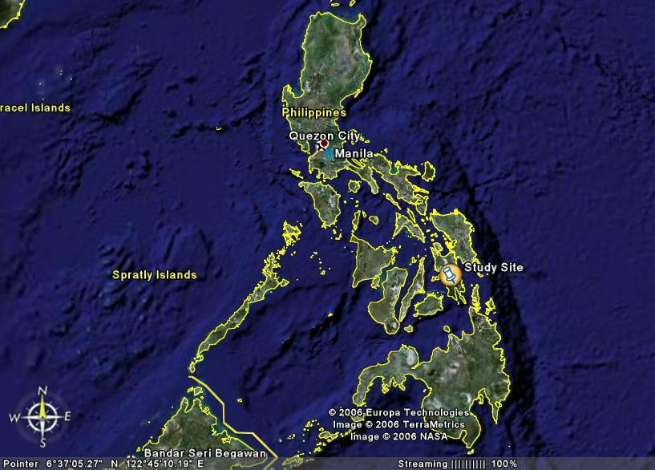

Figure1. Satellite image of the Philippine islands showing the general location of the study site (adopted from Google Earth, 2006).

Floral Assessment

A total of 27 (20 m x 20 m) purposive sampling plots were laid out within the study site: 9 plots within the protected zone, 9 within the buffer zone, and 9 within the multiple-use zone. Due to financial limitation, only specific mountain ecosystems within each zone were studied at approximately 10% sampling intensity. All plants were identified (except for seedlings 15 cm and below in height which are very difficult to identify) and their frequency of occurrence recorded. Sample specimens for unidentified species were collected and brought to the herbaria of the College of Arts and Sciences and the College of Forestry and Natural Resources at the Visayas State University for identification. Other unidentified specimens were brought to the University of the Philippines Los Baños, Laguna and identified by an expert of the College of Arts and Sciences. Plant taxonomy books and other related illustrated references which included Salvosa (1963), de Guzman et al. (1986), de Guzman and Fernando (1986), Santos (1986), Zamora and Co (1986), Fernando et al. (2004), were also used to identify unknown specimens. The remaining unidentified specimens were labeled according to their local names or chronological numbers for biodiversity index calculation.
The following formulas were adopted with modifications from Caldas et al. 2000:

Number of individuals per species in sampling area (equation 1)
a. Population density=
3600 m²

Where: 3600 m²=aggregate area of the nine sampling plots in each zone
Number of individuals per species (equation 2)
b. Relative density=
Total number of individuals for all species

c. Shannon-Weiner Index of Diversity (H)
s
H’ = -∑ Pi (lnPi) (equation 3)
i=1

Where: S =number of species
Pi=proportion of total sample belonging to ith species (use relative density)

d. Shannon-Weiner Index of Evenness (J)

H’ H’ H’
J = = = (equation 4)
H’max log_{e} S ln S

e. Simpson Index of Dominance (C)
s
C = ∑ Pi ² (equation 5)
i=1
f. Simpson Index of Diversity (D)
1
D = (equation 6)
C
Faunal Assessment

Primary data for the different mammals, birds, reptiles and amphibians in the study site were gathered through actual survey (encounter method) while secondary data were gathered through key informant interviews (i.e. triangulation approach). Photographic guides and illustrated references of different faunal species which included Buckles (undated), Rabor (1986), Alcala (1986), Fisher and Hicks (2000), Bartlett et al. (2001) and Lastica (2005) were used as references during the interviews (Figures 2 and 3).

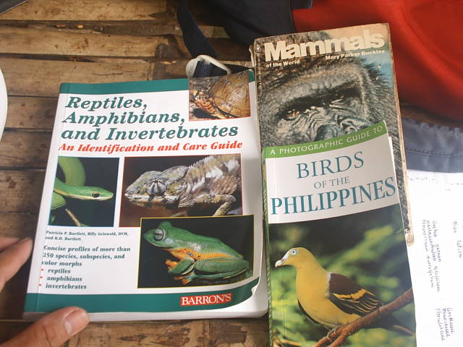 | 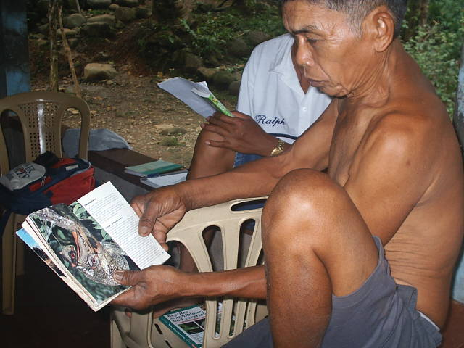
Figure 2. Three of the photographic guides of different faunal species used during the ethno-faunal assessment | Figure 3. One of the respondents (former wildlife hunter) interviewed during the ethno-faunal assessment

RESULTS AND DISCUSSION

Flora assessment

The floral diversity within the different zones of the CBFM Project showed that the site indeed contained various floral species. A total of 1,903 plants belonging to 325 species were recorded during the actual field data collection. The protected zone contained the most number of trees per ha followed by the buffer zone and then the multiple-use zone. On the other hand, there were more shrubs found in the multiple-use zone than in the other zones (Table 1) which could be attributed to the previous cutting operation. However in a per hectare basis, there were more plants in the buffer zone followed by the protected zone and then the multiple-use zone.

Table 1. Total count by category of floral species recorded within the different zones of the CBFM Project, Leyte, Philippines, 2005.

Plant Category | Location/Plant Count
Plant Category | Protected Zone | Buffer Zone | Multiple-Use Zone
Trees | 477 | 455 | 355
Shrubs | 38 | 34 | 62
Herbs | 42 | 52 | 52
Palms | 18 | 34 | 16
Vines/Liana | 23 | 31 | 51
Grasses/Sedges | 5 | 14 | 12
Ferns | 42 | 56 | 31
Epiphytes/Orchids | 3 | 0 | 0
Total (within nine plots) | 648 | 676 | 579
Total (per ha) | ≈1800 | ≈1878 | ≈1609
≈rounded to nearest whole number

In terms of species richness, the multiple-use zone contained the most numerous species followed by the buffer zone and then the protected zone (Table 2 and Appendix Table 1). It appeared that a certain site like the multiple-use zone under this study would become more diverse if it is subjected to some form of disturbance and then allowed to regenerate naturally. As mentioned earlier, the multiple-use zone was the most disturbed among the three zones but remarkably it contained more plant species. But these species are mostly small shrubs with less economic values which are remnants from the previous tree cutting operations in the site. This site is the most accessible and thus was subjected in the 1970’s to cutting operations by the local people for house and other light construction purposes. With the implementation of the CBFM project in 2001, cutting was finally stopped resulting to the emergence of the said shrubs.

It seems that habitat disturbance as in the case of multiple-use zone paved the way towards higher species richness. This phenomenon has been actually observed in several areas in the Philippines. For example, Dipterocarp forest which is one of the climax vegetation in the country is dominated by Dipterocarp species. Personal observation showed that five to ten years after logging operation within such forest ecosystem, various pioneer species like Trema orientalis, Macaranga tanarius, Mussaenda philippica, Commersonia bartramia, Antidesma bunuis, Artocarpus species and many others including several species of grasses and strangling figs usually emerge creating a more diverse vegetation type. As succession progresses and follows its normal route without anthropogenic perturbations, the climax Dipterocarp forest with less species richness will again develop. This implies that the removal of disturbance within the multiple-use zone will lead to the resurgence of few but dominant climax species particularly Dipterocarps. Maintaining the level of disturbance would also maintain such diversity within the multiple-use zone. But the fullest extent of disturbance to maintain an optimum level of diversity in the site is unknown. Further destruction of the current floral diversity level might have negative implications on soil and water resources. Good that the CBFM contract specified that farmers there are no longer allowed to expand their cultivation. This has partly maintained the level of floral diversity of the site in addition to the protection measures imposed by the people’s organization (PO) managing the project site.

Table 2. Categorical diversity indices of floral species found in the different zones of the CBFM Project, Leyte Philippines, 2005.

Biodiversity Indexes | Protected Zone | Buffer Zone | Multiple-use Zone
Number of Species | 174 | 182 | 193
Population Density (plants per ha) | 1800 | 1878 | 1609
Shannon-Weiner Index of Diversity | 1.097 | 1.192 | 1.306
Shannon-Weiner Index of Evenness | 0.213 | 0.229 | 0.248
Simpson Index of Dominance | 0.655 | 0.473 | 0.407
Simpson Index of Diversity | 1.526 | 2.113 | 2.455

The buffer zone, which ranked second in species richness, had also undergone some degree of perturbations but lesser in intensity compared with the multiple-use zone. Some portions along the slopes were actually slashed and burnt before. It was quite fortunate that the considerable distance of that zone from the lowland and the presence of wild pigs that consumed the root crops and bananas in all farms have discouraged local people from expanding their farming system. Some farmers have also migrated to other places looking for better livelihood opportunities, thus abandoning some cultivated areas in the said zone. Besides, the smallholders (people’s organization protecting the project) were able to stop illegal logging within the project site. These situations have given the vegetation the opportunity to regenerate naturally.

The protected zone had the least number of species among the three zones. This could be due to the absence of disturbance compared to the other two zones or to the presence of more dominant species that hindered the opportunity of other species to occupy and flourish within the site. In terms of diversity using both Shannon-Weiner and Simpson indexes, the multiple-use zone showed the highest value followed by the buffer zone and then the protected zone. On the other hand, the Simpson index of dominance showed an opposite trend. The dominance value for the multiple-use zone was the lowest while the protected zone was the highest (Table 2).

Table 3. Dominant floral species found within the different zones of the CBFM Project, Leyte, Philippines, 2005.

Plant Category | Protected Zone | Buffer Zone | Multiple-Use Zone
Trees | Callophyllum species  Diospyrus pilosanthera  Myristica philippinensis  Parashorea malaanonan  Strombosia philippinensis | Callophyllum species  Diospyrus pilosanthera  Parashorea malaanonan  Strombosia philippinensis  Vatica manggachapoi | Artocarpus species  Diplodiscus paniculatus  Leucosyke capitellata  Macaranga tanarius  Pterospermum diversifolium
Shrubs | Astronia clerodendron  Aralia species | Leea philippinensis  Aralia species | Ficus pseudopalma  Ficus arisana
Herbs | Begonia species  Kolowratia elegans | Elephantopus tomentosus  Kolowratia elegans | Homolomena philippinensis  Leea aculeata
Palms | Caryota cumingii  Calamus species | Caryota cumingii  Calamus species | Arenga tremula  Caryota cumingii
Vines/liana | Lygodium species  Derris species | Lygodium species  Derris species | Lygodium species  Philodendron species
Grass/sedge | Dinoclooa locuniae  Scleria scrubiculata | Dinoclooa locuniae  Scleria scrubiculata | Dinoclooa locuniae  Scleria scrubiculata
Ferns | Selaginella cuppressina  Cyclea mirrillii | Selaginella cuppressina  Cyclea mirrillii | Selaginella cuppressina  Tectaria crenata
Epiphytes | Calanthe hernisi | None | None

From the multiple-use zone towards the protected zone, changes in vegetation types are readily observable (Table 3). Commonly observed tree species within the multiple-use zone are pioneers like Macaranga tanarius and Artocarpus sp. which are indicators of site disturbance like the tree cutting operation mentioned above. Artocarpus blancoi and Artocarpus ovatus are only found within the multiple-use zone. As one moves from the multiple use zone to the buffer and protected zones, he could find premium species like Dipterocarps (e.g. Parashorea malaanonan and Vatica manggachapoi) and Ebena species like Diospyrus pilosanthera. Artocarpus blancoi and Artocarpus ovatus were no longer observed. Other important Dipterocarp species like Shorea contorta, Hopea malibato, and Shorea polysperma are also found in such zones. According to the key informants, these important species were found at the multiple-use zone in the 1960’s. The cutting operations in the 1970’s as mentioned were responsible why these species are no longer found within such zone. Giant ferns (Cyclea mirrillii) were only found at the protected and buffers zones which could be due to the elevation while Selaginella cuppressina are adopted in all zones. The overall observation of this study showed that both protected and buffer zones have closely similar vegetation composition which could be due to the minimal disturbance intensity.

Faunal assessment

The site is a haven to various species of mammals, birds, amphibians, and reptiles. A total of 93 species were recorded throughout the conduct of this research, namely: 1) mammals with 11 species belonging to nine families, 2) birds with 39 species belonging to 20 families, 3) reptiles with 16 species belonging to nine families, and 4) amphibians with 27 species belonging to five families.

Observed during the survey included the Philippine monkey (Macaca fascicularis), Philippine flying fox (Pteropus vampyrus), water monitor (Varanus salvator), common field rats (Rattus rattus), endangered rufous (Bucerous hydrocorax) and tarictic (Penelopides panini) hornbills, swiflets (Collocalia esculenta), flying lemur (Cyanocephalus volans), reticulated python (Python reticulata) and venomous viper (Trimeresurus flavomaculatus). Ethno-faunal assessment also revealed that indeed the site is a refuge to various species of animals (Table 4). Some species however were held captive by some residents in the adjacent villages of the CBFM Project site as home decoration. Photographs of some faunal species are shown on the appendices (Photographs 1-9).

Table 4. Faunal species observed and ethno-faunally assessed within the CBFM project site, Leyte, Philippines, 2005.

Common Name | Scientific Name | Family Name | Basis |  |  | Location
Mammals
Philippine Monkey | Macaca fascicularis | Cercopithecidae | O |  |  | All Zones
Philippine Deer | Cervus mariannus | Cervidae | E |  |  | PZ
Philippine Flying Lemur* | Cyanocephalus volans | Cyanocephalidae | O |  |  | All Zones
Philippine Field Rat | Rattus rattus | Muridae | O |  |  | All Zones
Philippine Flying Fox | Pteropus vampyrus | Pteropidae | O |  |  | PZ, BZ
Fruit Bat | Rousettus sp, | Pteropidae | O |  |  | All Zones
Tree Squirrel* | Sundasciurus philippinensis | Sciuridae | E |  |  | All Zones
Philippine Warty Pig* | Sus barbatus | Suidae | E |  |  | PZ, BZ
Philippine Tarsier | Tarsius syrichta | Tarsiidae | E |  |  | All Zones
Malay Civet | Viverra tangalunga | Viverridae | E |  |  | PZ,BZ
Common Palm Civet | Paraduxuros philippinensis | Viverridae | E |  |  | All Zones
Avian/Birds
Osprey | Pandion haliaetus | Accipitridae |  | E |  | All Zones
Philippine Hawk Eagle* | Spizaetus philippinensis | Accipitridae |  | E |  | All Zones
Philippine Falconet | Microhierax erythrogenys | Accipitridae |  | E |  | All Zones
Crested serpent eagle | Spilornis cheela | Accipitridae |  | E |  | All Zones
Philippine dwarf kingfisher* | Ceyx melanurus | Alcedinidae |  | E |  | All Zones
Swiftlet | Collocalia esculenta | Apodidae |  | O |  | All Zones
Rofous Hornbill* | Bucerous hydrocorax | Bucerotidae |  | O |  | PZ, BZ
Tarictic hornbill | Penelopides panini | Bucerotidae |  | O |  | PZ, BZ
Philippine Nightjar | Caprimulgus manillensis | Caprimulgidae |  | E |  | All Zones
Emerald Dove | Chalcophalps indica | Columbidae |  | O |  | All Zones
White-eared brown dove | Phapetriron leucotis | Columbidae |  | O |  | All Zones
Zebra dove | Geopelia striata | Columbidae |  | O |  | All Zones
Reddish coco dove | Macropygia phasianella | Columbidae |  | E |  | All Zones
Pompadour green pigeon | Treron pompadora | Columbidae |  | E |  | All Zones
Spotted dove | Stretopelia chinensis | Columbidae |  | O |  | All Zones
Common crow | Corvus macrorhynchos | Corvidae |  | O |  | All Zones
Philippine coucal | Centropus viridis | Cuculidae |  | O |  | All Zones
Philippine Fairy Bluebird | Irena cyanogaster | Irenadae |  | O |  | All Zones
Olive backed sunbird | Nectarinia jugularis | Nectariniidae |  | O |  | All Zones
Gray-hooded sunbird | Aethopyga primigenius | Nectariniidae |  | O |  | All Zones
Metallic-winged sunbird | Aethopyga pulcherrima | Nectariniidae |  | O |  | All Zones
Black-naped oriole | Oriolus chinensis | Oriolidae |  | O |  | All Zones
Wild chicken | Gallus gallus | Phasianidae |  | E |  | All Zones
White-bellied Woodpecker | Dryocopus javensis | Picidae |  | E |  | All Zones
Frogmouth | Batracostomus septimus | Podargidae | O |  |  | All Zones
Guaiabero | Bolbopsittacus lunulatus | Psittacidae | E |  |  | All Zones
Collasisi /Parakeet | Lariculus philippinenesis | Psittacidae | O |  |  | All Zones
Blue crowned racquet tail | Prioniturus discurus | Psittacidae | O |  |  | All Zones
Blue-crowned Racquet | Prioriturus discursus | Psittacidae | O |  |  | All Zones
Yellow vented bulbul | Pycnonotus goiaver | Pycnonotidae | E |  |  | All Zones
Philippine bulbul | Hypsipetes philippinus | Pycnonotidae | O |  |  | All Zones
Common moorhen | Gallinula chloropus | Rallidae | E |  |  | All Zones
White-breasted waterhen | Amaurornis phoenicurus | Rallidae | E |  |  | All Zones
Asian glossy starling | Aplonis panayensis | Stumidae | O |  |  | All Zones
Coleto | Sarcops calvus | Stumidae | E |  |  | All Zones
Streaked ground babbler | Ptilocichla mindanensis | Timaliidae | E |  |  | All Zones
Leyte Tit Babbler | Macronous leytensis | Timaliidae | E |  |  | All Zones
Philippine Eagle Owl * | Bubo philippinensis | Tytonidae | E |  |  | PZ, BZ
Grass owl | Tyto capensis | Tytonidae | E |  |  | All Zones
Philippine Scops-owl | Otus megalotis | Tytonidae | E |  |  | All Zones
Reptiles
Leyte Catsnake | Bioga angulata | Colubridae | E |  |  | All Zones
Elongated-headed tree snake | Ahaetulla prasina | Colubridae | E |  |  | All Zones
Arboreal rat snake | Gonyosoma oxycephalum | Colubridae | O |  |  | All Zones
Sailfin Water Lizard | Hydrosaurus pustulatus | Agamidae | O |  |  | All Zones
Common Flying Lizard | Draco spiloptera | Agamidae | O |  |  | All Zones
Yellow-gray banded snake | Calliophis calligaster | Elapidae | O |  |  | All Zones
Common Cobra | Naja naja | Elapidae | O |  |  | All Zones
King Cobra | Ophiophagus hannah | Elapidae | E |  |  | All Zones
Fresh-water Turtle | Cuora amboensis | Emydidae | E |  |  | All Zones
Common Gekko | Gekko gecko | Gekkonidae | O |  |  | All Zones
Common House Gecko | Hemidactylus frenatus | Gekkonidae | O |  | All Zones
Reticulated Python | Python reticulatos | Pythonidae | O |  | All Zones
Common Mabouya | Mabuya multifaciata | Scincidae | O |  | All Zones
Green Tree Skink | Lamprolipes smaragdina | Scincidae | O |  | All Zones
Water Monitor | Varanus salvator | Varanidae | O |  | All Zones
Pit Viper | Trimeresurus flavomaculatus | Viperidae | O |  | All Zones
Amphibians
Common Toad | Bufo marinus | Bufonidae | O |  | All Zones
Narrow mouthed frog | K. walteri | Microhylidae | E |  | All Zones
Truncate-toad narrow mouthed frog | Kaloula conjuncta | Microhylidae | O |  | All Zones
Slender digit narrow mouthed frog | K. picta | Microhylidae | E |  | All Zones
Malayan horned frog | Megoprys montana | Pelobatidae | O |  | All Zones
Pelobatid frog | Leptobrachium visayanus | Pelobatidae | O |  | All Zones
Corrugated forest frog | Platymantis corragatus | Ranidae | E |  | All Zones
Common forest ground frog | P. dorsalis | Ranidae | E |  | All Zones
For further identification | P. luzonensis | Ranidae | E |  | All Zones
Isolated forest frog | P. insulatus | Ranidae | E |  | All Zones
Negros cave frog | P. spelaeus | Ranidae | E |  | All Zones
For further identification | P. sp | Ranidae | E |  | All Zones
Giant Philippine frog* | Rana magna magna | Ranidae | E |  | PZ, BZ
Variable back frog | R. signata | Ranidae | E |  | All Zones
For further identification | R. vittigerra | Ranidae | E |  | All Zones
Woodworth’s frog | R. woodworthi | Ranidae | E |  | All Zones
Green Paddy Frog | R. earythraea | Ranidae | O |  | All Zones
Common Green Frog | R. everitti | Ranidae | E |  | All Zones
For further identification | R. mangyanurum | Ranidae | E |  | All Zones
For further identification | R. similis | Ranidae | E |  | All Zones
For further identification | R. sp | Ranidae | E |  | All Zones
Small-headed Frog | Occidozyga laevis | Ranidae | O |  | All Zones
Common Tree frog | Polypedates leucomystax | Rhacophoridae | E |  | All Zones
Rough-armed tree frog | Rhacophorus apendiculatus | Rhacophoridae | E |  | All Zones
Variegated tree frog | Philautus bimaculatus | Rhacophoridae | E |  | All Zones
Gliding Tree Frog | R. pardalis | Rhacophoridae | E |  | All Zones
Spiny tree frog | Edwardtayloria spinosa | Rhacophoridae | O |  | All Zones
O=Observed; E=Ethno-faunally assessed; *=Threatened species (Source: IUCN 2003-2007 Redlist), PZ=protected Zone, BZ=Buffer Zone, MUZ=Multiple-use zone

While the result of the survey is quite impressive, faunal diversity of the site is actually threatened by wildlife hunting and not by land use like agricultural cultivation under the current situation. The connection between land use and its impact on faunal diversity cannot be clearly established at this point in time. However, if agricultural areas would expand and slash and burn farming system becomes rampant, faunal diversity would certainly decline as wildlife habitats decline. In the last seven years, about 18 illegal tree cutting operations were apprehended. Thanks to the PO for protecting the site which maintained the wide haven for faunal species. However, as mentioned earlier, these faunal species are not totally safe due to wildlife hunting.

There are eight species considered threatened under the IUCN redlist (due to hunting either for food or trade) that are still present in the area. Of the eight faunal species, the Philippine warty pig is the most hunted animal in the site for its admirable meat. In addition, the Philippine deer, though not in the IUCN redlist, is also a threatened species in the country since it is commonly hunted also for its excellent meat. Hornbills and collasisi are also captured for sale as pets. Despite the information and education campaign (IEC) on biodiversity conservation conducted by the PO protecting the CBFM Project, many are still hunting these faunal species. Respondents during the ethno-faunal triangulation assessment revealed, though they cannot provide the accurate count, that these animals are getting less and less in number. Hence, at present the remaining few are only found in the upper, rugged portion of the project site. Species like monkeys, tree squirrel, tarsier, fruit bats, flying lemur, palm civet and field rats are still found in all zones while hornbills are only seen at the protected and buffer zones (Table 3).

Wildlife hunting has become a way of life for some local people residing within the vicinity of the project site even before the project establishment in year 2001. In fact, during the conduct of this study, three wildlife hunters were found roaming around the project site. The intensity of hunting and the total number of hunters in the area is however unknown since the area is wide and monitoring such is difficult. This difficulty is made thornier by financial constraints. But expectedly, the increasing population within the vicinity will eventually trigger more people to hunt wildlife in the site for survival, particularly when job opportunities for these people are not available. Poverty is one of the multifarious issues affecting biodiversity programs in the Philippines. In the Province of Leyte, Philippines alone, nearly half of the rural populace is living in poverty. Financially-constrained inhabitants in the uplands are inclined to engage in whatever livelihood opportunities are available including wildlife hunting in order to survive. This situation would further threaten the already-threatened biodiversity frontier in Leyte. Socio-economic and biodiversity conservation are very complex issues in the country. Information and education campaign (IEC) alone is insufficient to answer these complexities. Looking for other possible solutions including livelihood programs becomes imperative. Sound government policies on this aspect need to be clearly formulated and implemented.

Another slowly emerging challenge in the area is ecotourism. While this is a potential source of income for the local people as payment for environmental services, it may endanger the area in terms of waste disposal and genetic erosion as some people are just throwing their wastes (e.g. plastics, cans, etc.) and gathering floral as well as faunal samples either for leisure, scientific, business or other unknown purposes. There is a need to clearly establish policies for ecotourism so that the same would contribute to biodiversity conservation in the area.

CONCLUSION

The floral and faunal diversity of the CBFM Project is still remarkable which is made possible through the effort of PO. Although the area is a secondary forest, findings from this study revealed its astounding biodiversity conditions. Hence, the said area at present is a rich gene bank of various species of plants and animals that helps regenerate within and the nearby environs. However, wildlife hunting due to poverty is a threat to the current biodiversity condition of the area. It is suggested that livelihood programs would be implemented hand in hand with IEC to maintain or improve biodiversity conditions of the remaining forest ecosystems protected by smallholders in the Province of Leyte, Philippines.

In addition, the study simply dwelled on identifying the different plants and animals within the project site. Another challenging task would be to determine their ecological functions (e.g. seed dispersal, pollination and pest control) and economic importance which would further justify their conservation.

Acknowledgment

I am grateful to the Southeast Asian Regional Center for Graduate Study and Research in Agriculture (SEARCA), German Academic Exchange Service (DAAD) of the Federal Republic of Germany, and the Commission on Higher Education (CHED) of the Republic of the Philippines for the financial support. Likewise, to the helpful people’s organization (CSVFA) for allowing me to conduct research in their CBFM project.

References

Alcala, A.C., 1986. Guide to Philippine flora and fauna: Amphibians and Reptiles. Volume X. Natural Resources Management Center, Ministry of Natural Resources and University of the Philippines.
Bartlett, P., Griswold, B., and R.D. Bartlett, 2001. Reptiles, amphibians, and invertebrates: An identification and care guide. Barron’s Educational Series, Inc. Hauppage, NY 11788.
Buckles, M.P., Undated. Mammals of the world. A Ridge Press Book. Bantam Books, Inc. 0-553-10118-8196.
Caldas, M.P., Cuevas, V.C., Sierra, Z.N., Cervancia, C.R., and M.T. Zafaralla, 2000. Laboratory guide in ecology. Environmental Biology Division, Institute of Biological Sciences, College of Arts and Sciences, University of the Philippines Los Baños, Laguna.
Costanza R. et al. 1997. The value of the world’s ecosystems services and natural capital. Nature 387 (May 1997).
Conservation International Philippines, 2002. Philippine Biodiversity Conservation Program (PRISMA CD 5). Manila: Conservation International Philippines.
CRMF, c2002. Community-based forest management project profile. Cienda-San Vicente Farmers Association, Cienda, Gabas, Baybay, Leyte.
Cunningham, W.P., Cunningham, M.A. and B.W. Saigo, 2000. Environmental Science: A global concern. 9th Edition. Mc-Graw Hill Co. Inc.
De Guzman, E.D., and E.S. Fernando, 1986. Guide to Philippine flora and fauna: Palms. Volume IV. Natural Resources Management Center, Ministry of Natural Resources and University of the Philippines.
De Guzman, E.D., Umali, R.U., and E.D. Sotalbo, 1986. Guide to Philippine flora and fauna: Dipterocarps and Non-Dipterocaprs. Volume III. Natural Resources Management Center, Ministry of Natural Resources and University of the Philippines.
Fernando, E.S., Sun, B.Y., Kong, H.Y., and K.S. Koh, 2004. Flowering plants and ferns in Mount Makiling. ASEAN-Korea Environmental Cooperation Unit.
Fisher, T. and N. Hicks, 2000. A Photographic guide to birds of the Philippines. New Holland Publishers (UK), Ltd.
Google Earth, 2006. Satellite image of the Philippines Islands. Available at www.googleearth.com.
IUCN, 2003-2007. Redlist of globally threatened species. Available at www.iucnredlist.org. Accessed November 26, 2007.
Lastica, E., 2005. Personal Files: Photographic guide to mammals, reptiles, amphibians, and birds of the Philippines. Silliman University CenTrop Zoological and Botanical Garden. Dumaguete City.
Lean, G. Hinrichen, D. and A. Markham, 1990. WWF atlas of the environment. Prentice Hall Press. New York, NY 10023.
Nebel, B. J. and R.T. Wright, 2000. Environmental Science: The way the world works. 7th Edition. Prentice-Hall, Inc. Upper Saddle River, NJ 07458.
Philippine Atmospheric, Geophysical and Astronomical Service Administration (PAGASA), 2007. Climatic condition in Eastern Visayas. VSU, Baybay, Leyte.
Rabor, D.S., 1986. Guide to Philippine flora and fauna: Birds and Mammals. Volume XI. Natural Resources Management Center, Ministry of Natural Resources and University of the Philippines.
Salvosa, F.M., 1963. Lexicon of Philippine Trees. Forest Products Research Institute. College, Laguna, Philippines.
Santos, J.V., 1986. Guide to Philippine flora and fauna: Bamboos and Grasses. Vol. IV. Natural Resources Management Center, Ministry of Natural Resources and University of the Philippines.
Schucking, H. and P. Anderson, 1991. Voices unheard and unheeded. In: Biodiversity: Social and Ecological Perspectives. World Rainforest Movement. ZED Books Ltd.
World Resources Institute (WRI), International Union Conservation Netwrok (IUCN) and United Nations Environment Program (UNEP). 1992. Global Biodiversity Strategy: Guidelines for Actions to Save, Study, and Use Earth’s Biotic Wealth Sustainably and Equitably. Washington D.C.: WRI, IUCN and UNEP.
www.panda.org 2005. Nobody knows how many species are being lost and existing. Accessed December 4, 2007.
Zamora, P.M. and L. Co, 1986. Guide to Philippine flora and fauna: Economic ferns, endemic ferns, and gymnosperms. Vol IV. Natural Resources Management Center, Ministry of Natural Resources and University of the Philippines.

APPENDICES

Appendix Table 1. Total number of plant species recorded within the various plots of the different zones of the CBFM Project, Leyte, Philippines. 2005.
Plant Categories | Plots
Plant Categories | 1 | 2 | 3 | 4 | 5 | 6 | 7 | 8 | 9

Protected Zone
Trees | 53 | 64 | 63 | 57 | 61 | 45 | 29 | 49 | 56
Shrubs | 7 | 4 | 6 | 2 | 2 | 6 | 2 | 4 | 5
Herbs | 6 | 4 | 7 | 6 | 4 | 4 | 3 | 3 | 5
Palms | 1 | 1 | 0 | 4 | 2 | 2 | 2 | 3 | 3
Vines/Liana | 2 | 2 | 2 | 5 | 5 | 0 | 3 | 0 | 4
Grasses/sedges | 1 | 0 | 1 | 1 | 1 | 0 | 0 | 0 | 1
Ferns | 7 | 5 | 3 | 2 | 6 | 7 | 4 | 6 | 2
Epiphytes/orchid | 0 | 0 | 0 | 1 | 1 | 0 | 0 | 1 | 0

Buffer Zone
Trees | 38 | 80 | 60 | 61 | 53 | 40 | 28 | 36 | 59
Shrubs | 10 | 9 | 3 | 0 | 3 | 3 | 2 | 4 | 0
Herbs | 11 | 5 | 7 | 3 | 5 | 2 | 5 | 10 | 4
Palms | 5 | 4 | 4 | 5 | 4 | 1 | 5 | 3 | 3
Vines/Liana | 3 | 8 | 4 | 3 | 4 | 2 | 0 | 4 | 3
Grasses/sedges | 4 | 1 | 1 | 3 | 0 | 0 | 1 | 2 | 2
Ferns | 14 | 6 | 4 | 3 | 4 | 7 | 5 | 7 | 6
Epiphytes/orchid | 0 | 0 | 0 | 0 | 0 | 0 | 0 | 0 | 0
Multiple-Use Zone
Trees | 38 | 36 | 41 | 21 | 36 | 42 | 56 | 46 | 39
Shrubs | 7 | 4 | 3 | 8 | 9 | 9 | 8 | 7 | 7
Herbs | 5 | 2 | 0 | 10 | 9 | 3 | 11 | 6 | 6
Palms | 2 | 2 | 2 | 1 | 3 | 1 | 2 | 3 | 0
Vines/Liana | 4 | 5 | 3 | 5 | 9 | 4 | 10 | 4 | 7
Grasses/sedges | 0 | 0 | 1 | 1 | 1 | 2 | 3 | 0 | 4
Ferns | 1 | 2 | 1 | 5 | 6 | 4 | 4 | 3 | 5
Epiphytes/orchid | 0 | 0 | 0 | 0 | 0 | 0 | 0 | 0 | 0

Photographs 1-9. Some faunal species observed in the study site, Leyte, Philippines, 2005.
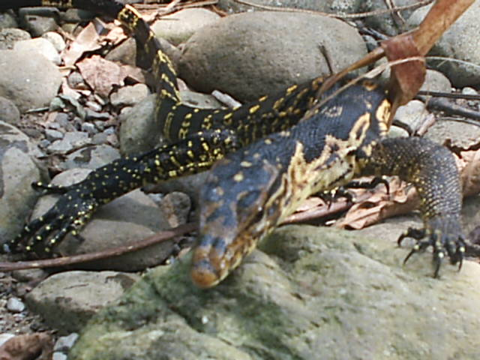 | 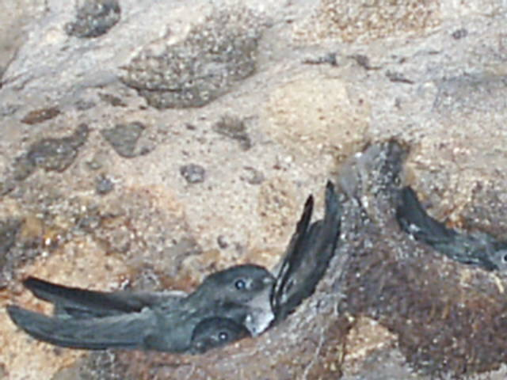 | 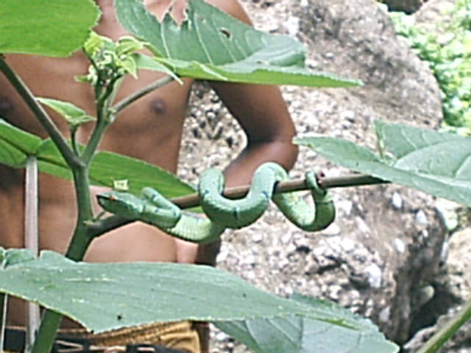
1. Monitor lizard* | 2. Swiftlet | 3. Pit viper
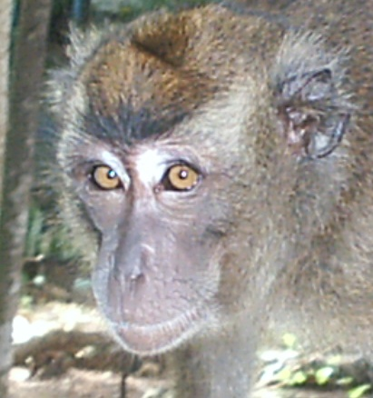 | 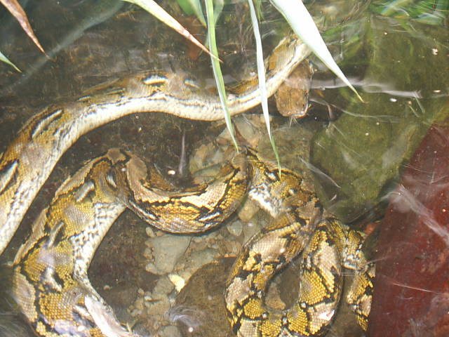 | 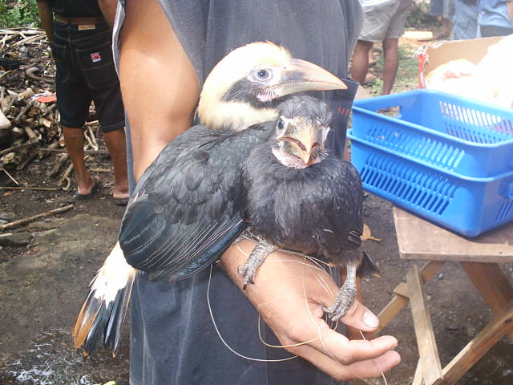
4. Philippine Monkey* | 5. Reticulated python | 6. Tarictic Hornbill*
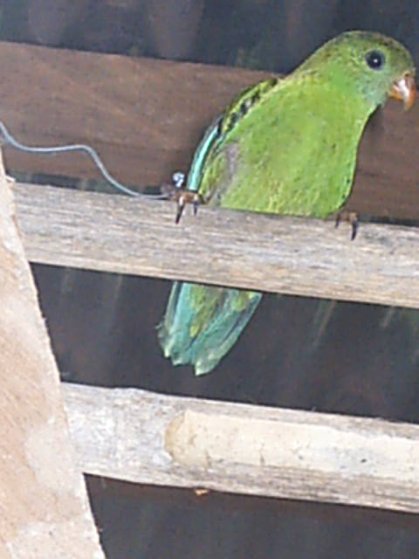 | 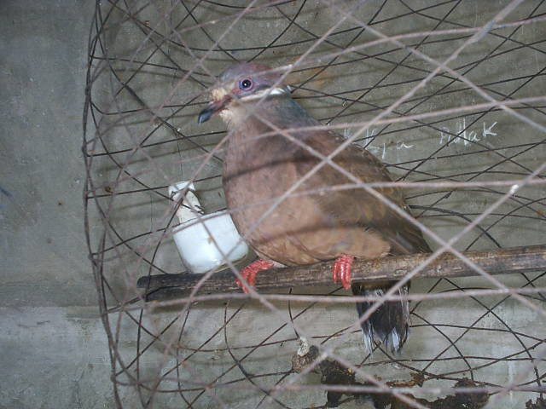 | 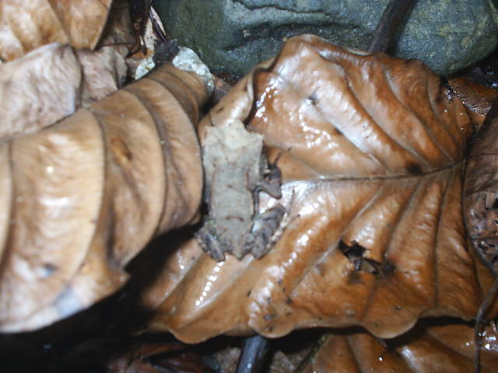
7. Collasisi* | 8. White-eared Brown Dove* | 9. Malayan Horned Frog
*Held captive by some local people within the villages adjacent to the CBFM Project site

