Theme : (10) - The role of forestry in poverty alleviation and in supporting human livelihoods in developing countries.

THE ROLE OF SOCIAL FORESTRY IN POVERTY ALLEVIATION – A CASE STUDY FROM INDIA

Dr. S. K. Sharma
Environmental Research Institute and,
Carman School, Dehradun 248007, India
E-mail : SKS105@rediffmail.com

ABSTRACT

The total forest cover of India as per State of Forest Report 2003 is 678,333 km², which constitutes 20.64 % of the geographic area of the country, plays a significant role in biodiversity protection, global environment conservation, landside prevention and soil preservation, headwater conservation, health, recreational and cultural, material production (timber, food such as mushroom etc, fertilizers, feeds, raw material for pharmaceutical and other industrial products, extracted ingredients, greening materials etc). The role of tropical evergreen forests raising the Willow (salix) and bamboos in the North-East India has been studied vis-à-vis employment generation and poverty alleviation through social forestry program

INTRODUCTION

The total forest cover of India of about 678,333 km² has a variety of habitats of ranging from tropical rainforests to alpine vegetation and from temperate forests to coastal wetland. India is also a center of agro biodiversity. It is a homeland of nearly 167 cultivated species and the global exchange of biota existed since historical times. The pre-historic Aryans in India were worshippers of nature. The epic Vedas and Upanishads were composed by our sages singing, “may the god, the water, the plants and the forest trees accept our prayer……..may the blessings of trees protect us forever”. The Puranas have said “one tree is equal to ten sons because trees means water, water means bread and bread is life”. Corroborating with the ancient Indian philosophers that man being an intelligent creature should have the protection of forests for various reasons. Thus, forests have protected and divided as follows in India.

Division of Indian Forests : Depending upon the climate, soil, relief and structure, Indian forests are divided into following as shown in the Forest Map of India:
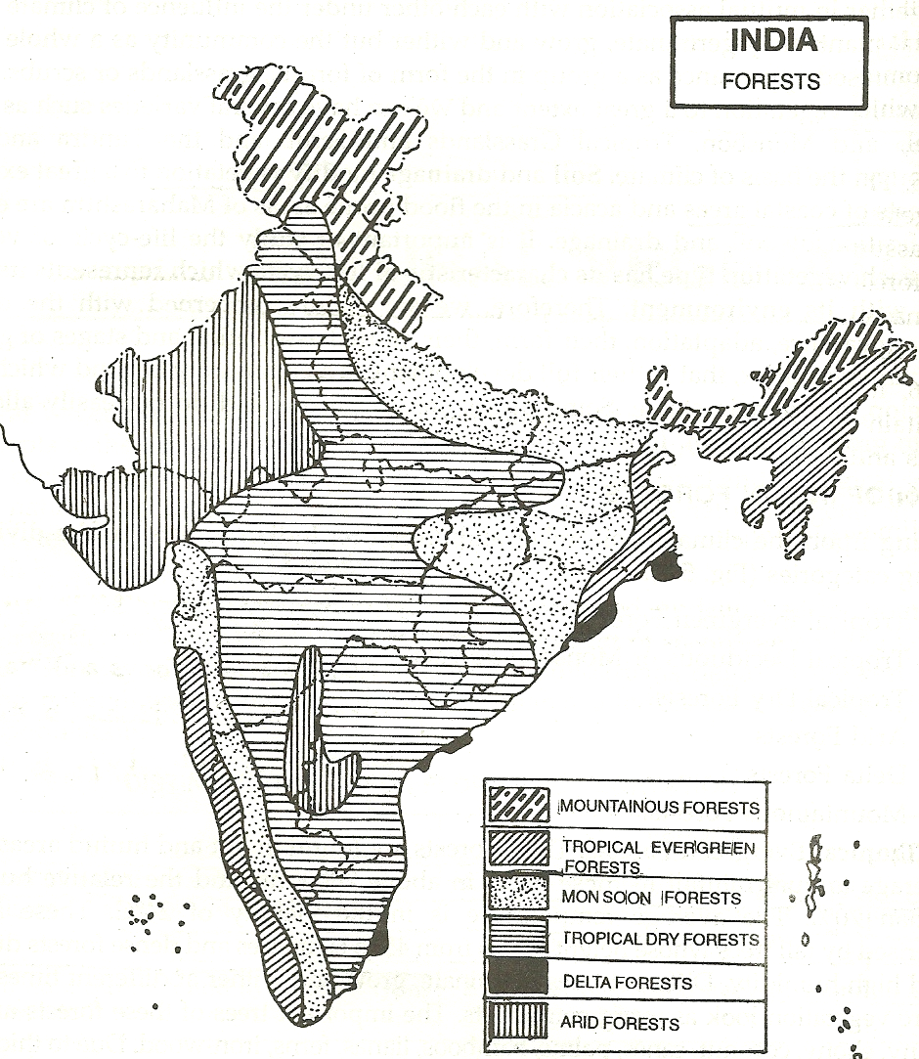
Forest Map of India
Tropical Evergreen Forests – These forests are found in hot and humid areas of India, having an average annual rainfall of about 200cm and relative humidity more than 70%. The average temperature is in the vicinity of 24⁰C. The areas are characterized by tall tress varying in height from 40 to 60m. The important trees are mahogany, ebony, coconut, canes, palms, bamboos, lianas and ferns, covering and area of about 5 million hectares in Andaman & Nicobar Islands, North-East States, West Bengal and on the western slopes of Western Ghats. These are hardwood forests and are not very important economically.
Tropical Deciduous or Monsoon Forests - These forests are found in receiving an annual rainfall between 100 to 200cm. They shed their leaves in beginning of summer season in the face of water shortage. They are about 30 to 45m tall and cover nearly 20% of our forested area. They grow over Western Ghats, middle and lower Ganga valley, and along the foothills of the Himalayas in the Shiwaliks. Sal, Teak, Shisham, Sandal wood and Khair are some of the important trees. These trees provide useful wood and dyes and are economically very important.
Tropical Dry Forests – Areas receiving 50 to 100cm of annual rainfall are covered by troical dry forests in Maharashatra, Andhra Pradesh, eastern part of Rajstahn, southern part of Uttar Pradesh, Tamil Nadu, Madhya Pradesh, Punjab, Haryana and Karnataka. Neem, Shisham, Babul, Pipal, Mango are the main trees. These are about 6 to 9m high and shed their leaves with the advance of summer season. Presently, they cover about 5 million hectares of land. The Neem tree has an excellent medicinal value whereas other threes either used for construction or as fruit trees.
Arid Forests – These forests are found in the areas of Rajsthan, Gujarat and Haryana where an annual rainfall is less than 50cm. The vegetation include small size Kikar, Babul and some thorny bushes and shrubs. Their wood is generally used as fuel.
The Delta or Tidal Forests - Mangrove is another species of trees of the tidal forests which is largely found in Sunderban delta formed by the river Ganga. The deltas of the river Mahanadi, the Godavari, the Krishna and the Cauvery and the Andaman and Nicobar Islands are also important areas where tidal forests are largely grown. The wood is used for boat construction by the fishermen to catch fishes as a part of earning the livelihood.
Mountain Forests – These forests are found in the mountain areas of India in the Himalayas and in the mountain areas of Peninsular India.
Himalayan Forests – these forests are found on the southern slopes of the Himalayan ranges. Dense trees of Oaks, Chestnuts, Sal and Pine are found between 1000 to 2000m altitude in West Bengal, Uttarakhand and Bihar. Broad leaved evergreen trees of Oak, Chestnuts, Cedars, Silver Fir, Spurce, Chinar and Deodar are common between 2000 to 3000m altitude in Kashmir Valley. Above 3000m elevation, the Alpine forests, pastures, Pines, Birches, Silver Firs and Confers are found below snowline in PirPanjal. The alpine and other forests which is helping in soil conservation especially in hilly areas and regulating the monsoon to feed the glaciers in Himalaya including the Gangotri glacier which is the largest one in the Himalaya and is 30.2 km long and 0.5-2.5 km wide that provides around 8.6 million m³ of water annually and supports one of India’s largest river basin, the Indo-Gangetic Basin in downstream where nearly 550 million poor people depend for their livelihood.
SOCIAL FORESTRY PROGRAM FOR POVERTY ALLEVIATION

The role of India's forests in the national economy and in ecology was further emphasized in the 1988 National Forest Policy, which focused on ensuring environmental stability, restoring the ecological balance, and preserving the remaining forests. Other objectives of the policy were meeting the need for fuel wood, fodder, and small timber for rural and tribal people while recognizing the need to actively involve local people in the management of forest resources. Also in 1988, the Forest Conservation Act of 1980 was amended to facilitate stricter conservation measures. A new target was to increase the forest cover to 33 percent of India's land area from the then-official estimate of 23 percent. In June 1990, the central government adopted resolutions that combined forest science with social forestry, that is, taking the socio-cultural traditions of the local people into consideration (joint forest management committees).

Out of this entire forest wealth, the author remained associated with a project on developing social forestry in the Tropical Evergreen Forests of North –East India for examining the its role in poverty alleviation. The north - eastern part of India is badly affected by the faulty agricultural practice of shifting cultivation that leads to degradation of land, therefore, social forestry assumes more important in this area than any other part of the country. Here, the forests meet nearly 40% of the energy needs in the form of fuel wood which is of the order of about 235 million m3 annually and the green fodder for livestock which is also of the order of 882 million tons per year making it 50% of the requirement while remaining is met by destructive over-grazing within forests. this has lead to massive deforestation

Seeing the problems of deforestation which has effected the livelihood of many - the National Commission on agriculture, government of India introduced the social forestry concept in 1976 to meet the following objectives :

* to reduce pressure from forests and making use of all unused, degraded and fallow land, involving farmers and local people in forestry activities.

* in addition to plantation of trees along railway lines, roadsides, river and canal banks, the plantation of some selected bamboo, poplar trees / willows were raised by common man so as to meet the growing demand for timber, fuel wood, fodder etc, thereby, reducing the pressure on traditional forest area and increasing the income of the family.

Under the Social Forestry program, the habitants of north - east India have been raising, Willow (salix) and bamboos as these have a great economic value as some of the industries depend on them and the elaborate infrastructure is not necessary. At the same time it is one of the easiest way to implement and also it is the most rewarding component of social forestry to reduce poverty and improve food security in an otherwise backward area where the country’s developmental benefits have not reached fully.

Large tree - salix alba (bis) and salix babylonica (majnu) – used for making light timber, pulpwood, cricket bats, matchwood, tool-handles, fuel and fodder

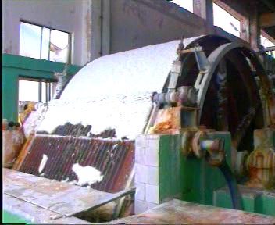

The above figures show the preparation of paper from the pulpwood obtained from Bamboo.

Small tree - salix daphnoides (bhashi, bashroi) – suitable for hut making, basket making, carpet making, fuel and fodder.

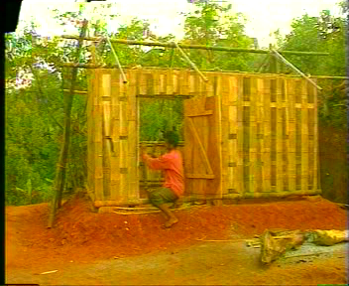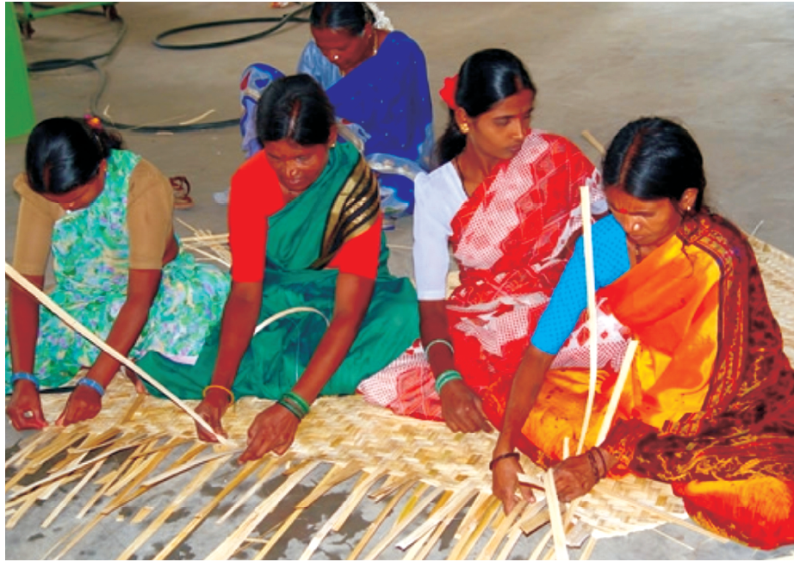

The above figures show a man busy with a hut construction and women in the carpet making

INITIATIVES FROM THE GOVERNMENT OF INDIA

People are at the centre stage of planning forest management in India. The national and state level planning with the participation of people started in 1991 in the form of joint forest management which emphasized development of partnership with forest fringe people and the government of India. Presently, there are 1,06,479 Joint Forest Management Committee’s managing an extent of 22.02 Mha involving 21.99 million people of forest area.
In addition, Government of India has now started encouraging the Eco-Tourism in the country which is still at a very nascent stage, but there are for sure conscious efforts to save forests and its biodiversity specially, the fragile Himalayan Eco System and culture and heritage of the indigenous people, which is probably the largest concentration in the world. But in the recent past, the movement of Eco-tourism in Himalayas (Kanziranga National Park – a well known spot for Rhinos) ) in the north-eastern part of India, is gathering momentum, not only for geological reasons but also by virtue of its archaeological, ecological and cultural values. Eco-tourism involving traveling to this relatively undisturbed natural areas with the specific objectives of studying, admiring and enjoying nature and its wild plants and animals as well as existing cultural aspects found in these areas. It stresses on the total environment while making an economic contribution and local community and is distinguished from mass tourism and general resort tourism by having a lower impact on the environment and require less infrastructure development. Such responsible travel to natural areas conserves the environment and improves the well-being of local people. Eco-tourism has also played a significant role in reducing the poverty of the local communities through employment generation based on the forests.

CONCLUSIONS

Social forestry is forestry by the people. Till now, lack of data on such forest resources and forest productivity resulted in a serious underestimation of their contribution to gross domestic product – a situation which almost always leads decision - makers to overlook the importance of the social forestry to livelihoods and national economic development. The activity of raising forest based products and their marketing as a part of social forestry in India, is a labor – intensive activity and large scale adoption of this program has not only taken employment to the very door-steps of the unemployed but has helped generate income through employment and through the sale of surplus goods and services thus, enhancing their contribution to the reduction of poverty.

ACKNOWLEDGEMENTS

Thanks to the Board of Trustees and all members of the Community Research and Development Centre for their support in various ways to ensure the successful completion of this work.

Thanks are due to a large number of people who have helped with the collection of data, reviewing of drafts, and patient explaining and clarification.
REFERENCES
Dhamija, S.K. (2005) Environmental Science, Kataria Publishers, New Delhi, pp 217
Mathew, K.M. (2008) Manorama Year Book, Kottayam, Kerala, pp 285-87
Rai, A.N. (2005) I.S.C. Environmental Education, Part 1, Goyal Brothers Prakashan,
New Delhi, pp 15-17
Shah, S.A. (1988) Forestry for people, Indian Council of Agriculture Research, New
Delhi, pp 2-3.

